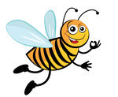
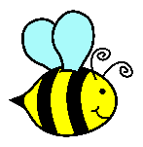
Year 2: Dance Buzz Task
Name:______________________ Due:__________________
Task: Your task individually is to create a creative and funky dance for the BeeBots to dance. Using your new knowledge of how to program the BeeBots you will program and then record using a video device your BeeBots dancing. Once all dances have been completed and videoed, as a class you will survey all students on what their favourite dance was. This will be recorded and then individually you will create an interactive graph using the BeeBots to show your results on a graph.
Checklist
- Fill out Activity 1: Identifying (4) different digital systems that can be programmed
- Fill out Activity 2: Plan a sequence of steps to make BeeBots dance
- Program BeeBots using Activity 2’s plan to dance (make sure that you program all of the steps into the BeeBots before pressing “Go” so the BeeBots complete the whole dance in one motion)
- Select a digital recording device: IPad or digital camera to record BeeBots dance
- Fill Out Activity 3: Survey the class on which dance was their favourite
- Using Activity 3 create an interactive graph showing the results of the survey

Important Dates (Note: Only the Activity Sheets and overall task have due dates. Other parts of the task will be completed to teachers planning)

- Activity 1 and Activity 2 Due: ________________________________
- Activity 3 Completed:______________________________________
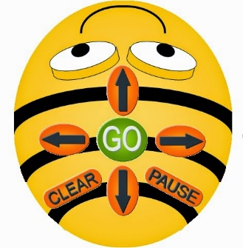
Activity 1: Identify Different Digital Systems
In the boxes below: Draw and name (4) digital systems that can be programed.
HINT: We have listed a number of these devices in class.
Digital System 1:____________________ | Digital System 2: ___________________
Digital System 3:___________________ | Digital System 4:____________________
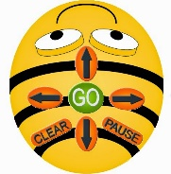
Activity 2: BeeBots Dance Sequence
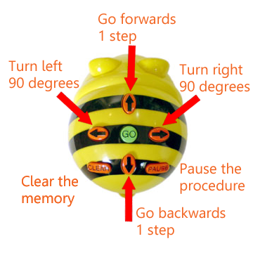
Using the programing buttons. Plan a sequence that you can use to program the BeeBots to dance. You need to have up to 10 steps in your sequence.

Example: Forward 3 steps, Turn right, Backwards 5 steps, Turn left, forward 2
Or

Remember to use this sequence when programing you BeeBots to dance
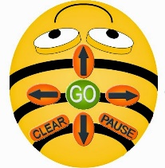
Activity 3: Graph our favourite dance
Using the tally table below: Decide as a class (5) dances that are the classes favourite dances. Survey the class and take tally of the number of students that liked each dance. Students can only vote on one dance.
Dance Name | Tally

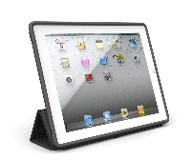
Using the Tally Table create an interactive graph using the BeeBots to show the results of the survey. Video record the interactive graph.
Unit: Dance Buzz Rubric
Year 2 Technologies Term 1, 2016 Name:___________________________________
Date Marked:____________________________
Assessable Criteria | A | B | C | D | E
 | Excellent | Good | Satisfactory | Developing | Limited
Identifies digital systems that can be programed | Identifies (4) digital technologies that can be programmed | Identifies (3) digital technologies that can be programmed | Identifies (2) digital technologies that can be programmed | Identifies (1) digital technology that can be programmed | With assistance identifies a digital technology that can be programmed
Create and generate a sequence of steps to make BeeBots dance | Create and generate a sequence of steps to make BeeBots dance all of the time | Create and generate a sequence of steps to make BeeBots dance with one or two errors | Create and generate a sequence of steps to make BeeBots dance most of the time | Create and generate steps to make BeeBots dance some of the time | With assistance can create and generate a sequence of steps to make BeeBots dance
Record BeeBots dance using a digital recording device | Records and plays back the BeeBots dance using a digital device | Records all of the BeeBots dance using a digital device | Records most of the BeeBots dance using a digital device | Records some of the BeeBots dance using a digital device | With assistance can record BeeBots dance
Create an interactive graph using BeeBots | Creates an entertaining graph using BeeBots to show most liked BeeBots dance | Creates an Adequate graph using BeeBots to show most liked BeeBots dance | Creates reasonably interactive graph using BeeBots to show most liked BeeBots dance | Creates a graph showing the most liked BeeBots dance | With assistance can create a graph to show most liked BeeBots dance

Comment:______________________________________________________________________________________________________________________________________________________________________________________________________________________________________________________________________________________________________________________________________ Mark:_____________

